https://apps.azleg.gov/BillStatus/BillOverview/80050?SessionId=128

https://azcapitoltimes.com/news/2024/02/13/arizona-could-become-latest-state-to-ban-attendance-related-suspensions/
(PDF attached and article below, too!)
------------------------------

Deposit Photos

Arizona could become latest state to ban attendance-related suspensions
By Maria Polletta, Arizona Center For Investigative Reporting//February 13, 2024//
This article first appeared on Arizona Center for Investigative Reporting and is republished here under a Creative Commons license.
An Arizona lawmaker is again trying to bar schools from using out-of-school suspensions to punish students who miss class, arguing the strategy is not only ineffective but harmful.
House Bill 2218 is Rep. Laura Terech’s second attempt to ban the practice of suspending Arizona students for tardiness and truancy, after a 2022 investigation by AZCIR and The Hechinger Report revealed the scope of the contentious disciplinary tactic in district and charter schools.
The AZCIR/Hechinger analysis, which relied on data from school systems representing about 61 percent of the state’s public school students, identified more than 47,000 suspensions for attendance violations over five school years. Black, Latino and Indigenous students received a disproportionate share of the punishments.

UPDATE: On Feb. 13, the House Education Committee voted unanimously to advance HB 2218. The measure is awaiting consideration by the full House.
Among districts in the AZCIR/Hechinger sample that suspended for attendance, missing class led to 10 percent of all suspensions, resulting in tens of thousands of additional missed days of school.
“Any time out of school is really harmful to kids’ long-term academic success,” said Terech, a Phoenix Democrat and former elementary school teacher. She pointed to a growing body of research that has tied missing just two days of school per month to lower reading proficiency in third grade, lower math scores in middle school and higher dropout rates in high school.
“It just doesn’t make sense to punish kids (for) time out of school with more time out of school,” Terech said.
Chronic absenteeism—defined as missing more than 10 percent, or 18 days, of school in an academic year—has long been a problem in Arizona, and rates have continued to balloon in the wake of the pandemic. About 14 percent of K-12 students were chronically absent in 2019, according to state data. By 2022, that figure had jumped to 34 pe

Arizona students had the worst rate of chronic absenteeism in the country in a recent analysis by national nonprofit Attendance Works. And some schools here have responded to rising absenteeism with even more attendance-related suspensions, contending the strategy can jolt students and parents into compliance.
A handful of lawmakers employed the same logic when opposing Terech’s initial bill last year, insisting attendance-related suspensions should have a place in schools’ disciplinary toolboxes. Though the measure advanced out of committee with bipartisan support, GOP leadership never brought it to the House floor for a vote.
This year, Terech’s bill has nearly twice as many Republican co-sponsors than Democrats, including Sen. T.J. Shope, who spent more than a decade serving on Coolidge Unified District’s school board.
“I just never really understood the idea that we’re going to punish a child who’s a truant by keeping them home,” Shope said, adding that he supports in-school suspension as a “corrective measure” because it at least keeps students on campus.
With out-of-school suspension, he said, “I just don’t know that there’s a lesson learned.”
Indeed, Lori Masseur of Read On Arizona, which convened a task force to address the spike in chronic absenteeism last spring, said there “currently is no significant research or data that suggests that suspensions reduce chronic absence or improve attendance.” At least 17 other states have already banned out-of-school suspensions in response to absenteeism.

Sign up. Get engaged.
Get AZCIR’s latest investigations and updates delivered straight into your inbox.

School districts across Arizona generally declined to take a position on the bill when contacted by AZCIR, with several noting they’d already shifted away from suspending for absences and tardies. A spokeswoman for Dysart Unified School District, one of the more punitive school systems in the AZCIR/Hechinger sample, said the district would comply with any new state directives and “would be open to alternative strategies that have proven to be effective.”
Terech said she hopes her bill will force lawmakers to consider how to combat rising rates of chronic absenteeism, even if her proposed approach ultimately isn’t successful. Other education advocates stressed that eliminating attendance-related suspensions is only one piece of a larger puzzle.
“We need stronger wraparound services. We need trusted adults on campus that kids connect with,” Terech said. “Things as simple as extracurricular activities and peer-to-peer accountability—those are all steps in the right direction. So, I’m very optimistic and hopeful that this will be a vehicle to have a broader conversation.”

RELATED
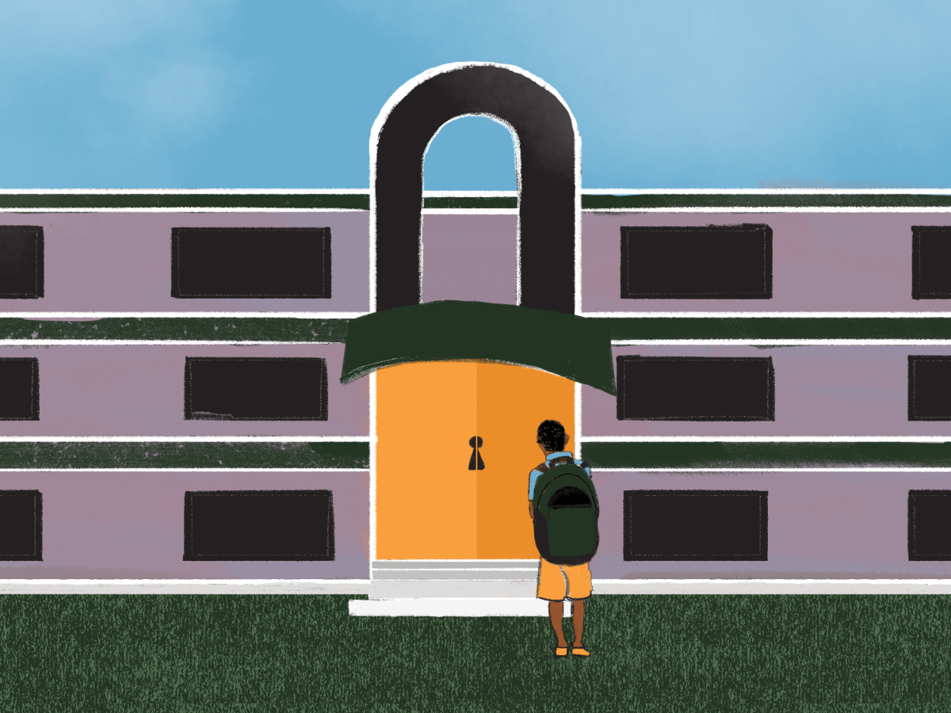

Suspending students for absences, tardies compounds learning loss
Suspending students for missing class, whether it’s because they showed up late, cut midday or were absent from school entirely, is a controversial tactic. At least 17 states forbid schools from suspending students for attendance problems at some level—if kids aren’t in class, they aren’t learning. Yet the practice is pervasive in Arizona, a first-of-its-kind AZCIR/Hechinger analysis has found, with students missing tens of thousands of additional school days as a result.
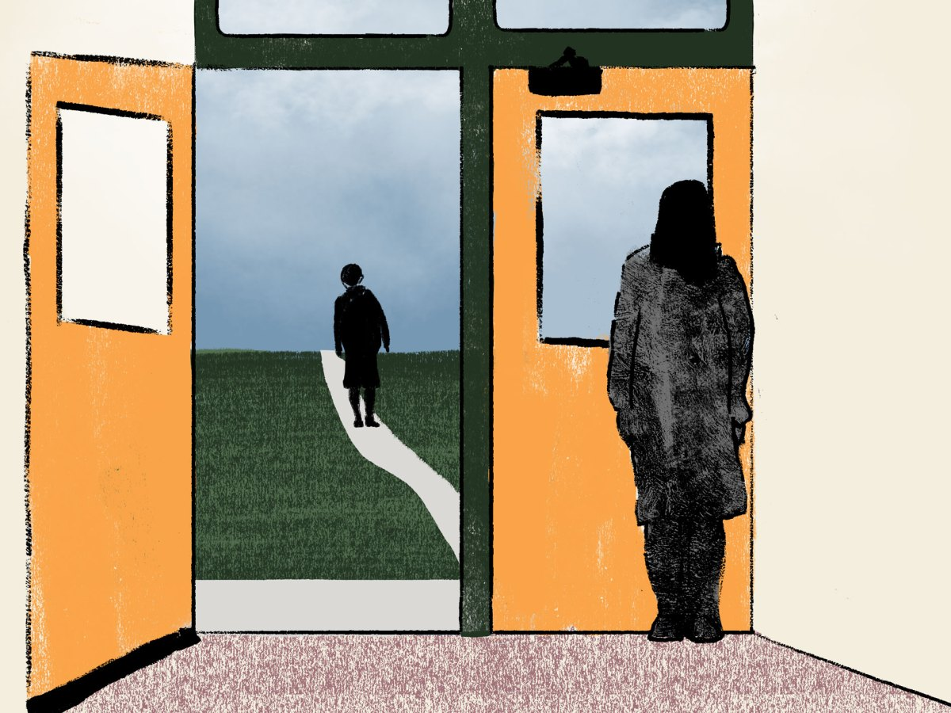

Overrepresentation of Black, Hispanic students among those suspended for missing school could violate civil rights law
A first-of-its-kind analysis of education data shows that Black, Latino and Native American students are frequently overrepresented among those blocked from class for missing class — what some argue is evidence of a potential civil rights violation. White students, meanwhile, were largely underrepresented.


In wake of pandemic, some districts take less-punitive approach to absenteeism
Though suspending students for attendance violations is widespread in Arizona, it is not universal—or necessary, according to school and district leaders who have found ways around it. They argue effective alternatives must make school a place students want to be, and treat absenteeism as a problem to solve, rather than a behavior to punish.
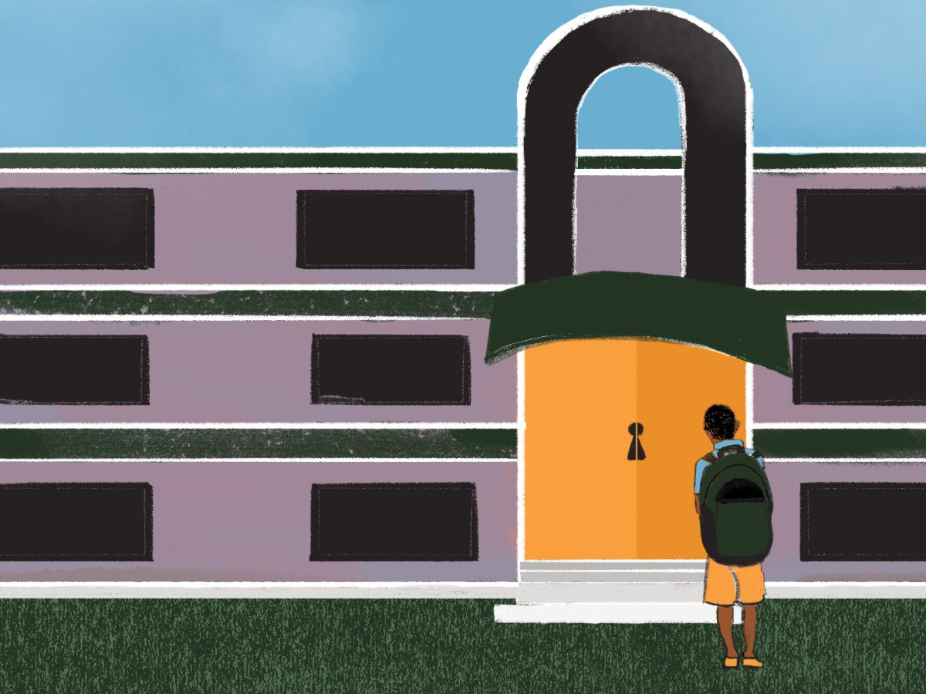

Inside our analysis of Arizona’s attendance-related suspensions
For the past year, the Arizona Center for Investigative Reporting and The Hechinger Report gathered and analyzed data for attendance-related suspensions among Arizona’s traditional district and charter networks that represent more than 60 percent of the state’s public school students. Here’s how we did the analysis.


Proposed bill to ban suspensions for attendance violations falls short
Rep. Laura Terech, a Democrat, crafted a bill in response to an investigation by AZCIR and The Hechinger Report, which revealed for the first time the scope of the controversial disciplinary practice of suspending Arizona students for tardiness and truancy.

