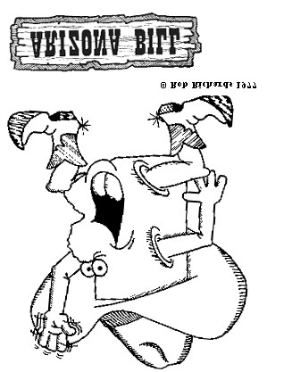

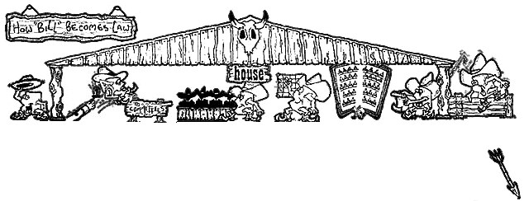
Arizona Bill is introduced in the House by a Member, a group of Members, a Standing Committee or a Majority of a Committee, after being written in proper form by the Legislative Council.
Bill is branded (assigned
a number), First Read and
referred by the Speaker
to appropriate Standing
Committees and to the
Chief Clerk for printing
and distribution.
Committees consider Bill
(
may include hearings, ex
-
pert testimony, statements
from citizenry). Reports
recommendations
to
Whole House. Committee
on Rules determines if Bill
is constitutional and in
proper form.
Committee on Rules
places Bill on
Active
Calendar and Speaker
sets order in which
measures will be con-
sidered.
Third Reading-Roll
Call. Every Member
present must vote
(
unless excused and
no Member may vote
for another Member.
If passed by House, Bill
goes on to the Senate.
Committee
of
the
Whole. Informal session
of entire House member-
ship acting as one com-
mittee. Debate, amend-
ment, recommendations
on Bills on Calendar.
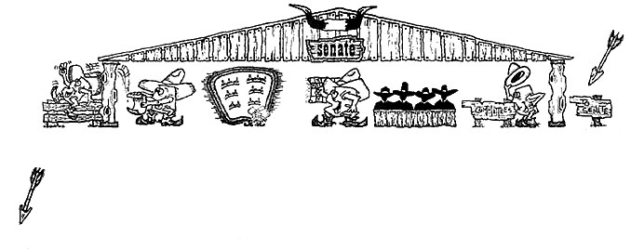
If passed by Senate (either in identical
form or amended by adding or delet-
ing material), Bill is sent back to
House...
Third Reading --
Names called alpha-
betically and unless
excused, each Sena-
tor present must vote
on each measure.
Committee of the
Whole. Entire mem-
bership of Senate acts
as one committee.
Debate, amendments
and recommenda-
tions on Bills on Cal-
endar.
Committee on Rules’
agenda becomes the
calendar for Commit-
tee of the Whole and
after 5 days President
designates which
measures are to be
placed on Active Cal-
endar of the Commit-
tee of the Whole.
Second Reading--
President refers Bill
to appropriate Stand-
ing committees.
Committees consider
Bill (May include
hearings, expert testi-
mony, statements
from citizenry). Re-
ports recommenda-
tions to entire Senate.
House Bill is First
Read in the Senate
and laid over one
day.
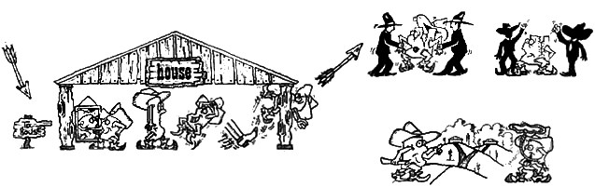
If Bill comes back to House
If Bill is identical to
measure originally
passed by House,
goes to Governor...
Bill may be ac-
cepted in new
form and sent to
Governor...
Bill is sent to Conference Committee made
up of Representatives appointed by the
Speaker and Senators appointed by the Presi-
dent -- each with own idea of how Bill should
Conference committee “mends” Bill by
accepting original version, by adding
new material, by deleting language or
in some way compromising dis-
agreements.
Bill may be rejected and
sent to a Conference
Committee
pass...
in different form (amended either
by addition or A Conference Committee Report is sent deletion of material back to each
House for
adoption and
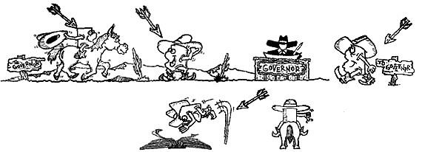
after Final Passage, Bill is sent
After Bill is received by Governor hav-
ing been passed by both House and
Senate, the Governor may sign Bill or
allow Bill to become law without his
signature if he takes no action during
next five days (or ten days after ad-
journment). Then Bill becomes law -
a part of the Arizona Revised
Statutes.
The Governor may veto Bill, but
must return Bill to House stat-
ing his reasons. The House and
Senate may override the
Governor’s veto by a two thirds
vote (or three-fourths, if an
emergency measure).
on to Governor…Arizona Revised Statutes

